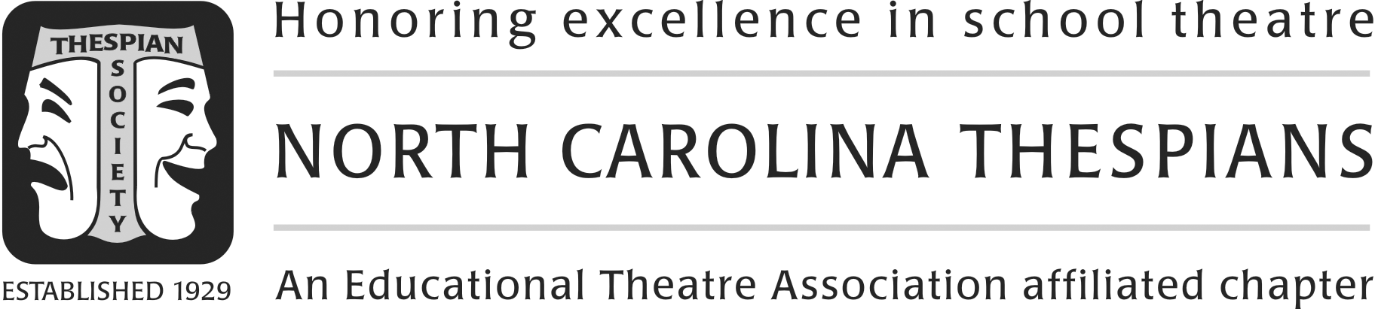
One-Act Showcase Evaluation Form 2018

CAST (or give adjudicators programs): _ TROUPE:
CAST (cont.): _
DIRECTOR: Director is ___student, ___troupe director/teacher.
PLAY TITLE: PLAYWRIGHT:
PUBLISHING COMPANY:
CRITERIA | SCORE  (circle one) | WRITTEN EVALUATION: Your comments on strengths and weaknesses provide the educational component of this process. Please provide feedback.
DIRECTION  - Staging  - Timing  - Pace  - Dramatic tension  - Establishment of mood/setting  - Utilization of space  - Effective sequence of action  - Clear, text-derived vision | Superior  Excellent  Good  Fair
ACTING  - Strong, active objectives evident  - Solid character development  - Projection/diction  - Interpretation of text  - Stage presence  - Use of body to convey character and facilitate objectives | Superior  Excellent  Good  Fair
TECHNICAL ELEMENTS  - Establishment of mood/setting  - Props/costumes/makeup consistent with theme, period, mood, setting  - Smooth set-up and strike  - Appropriate use of sound/music (if applicable)  - Effective overall design | Superior  Excellent  Good  Fair
OVERALL PRESENTATION  - Choice of material  - Age appropriate  - Challenging to ensemble  - Commitment to the literary/dramatic values  - Entrants’ talents well showcased  - Effective ensemble | Superior  Excellent  Good  Fair
OVERALL RATING: Superior Excellent Good Fair
Additional comments:

_______________________________
Adjudicator signature

